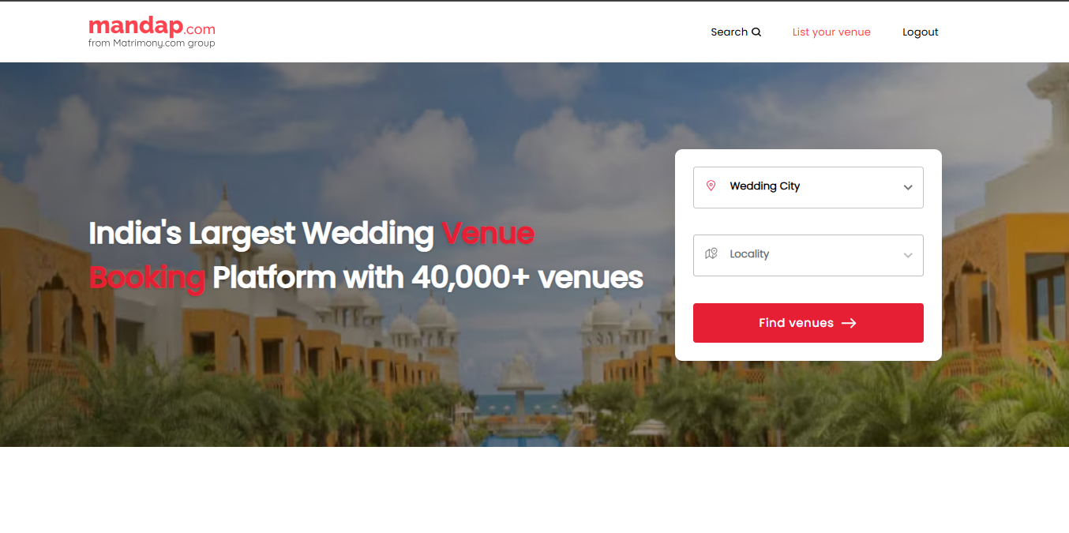 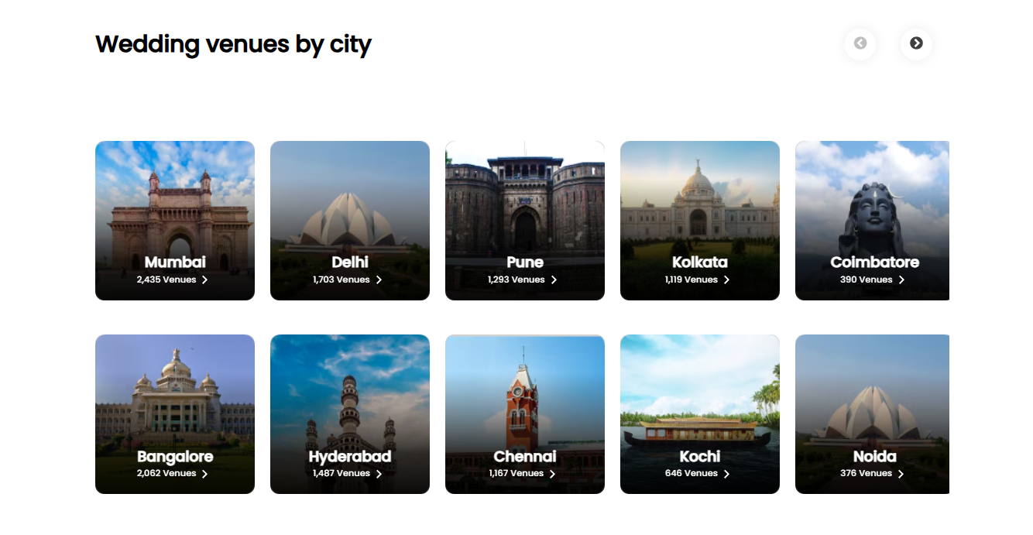

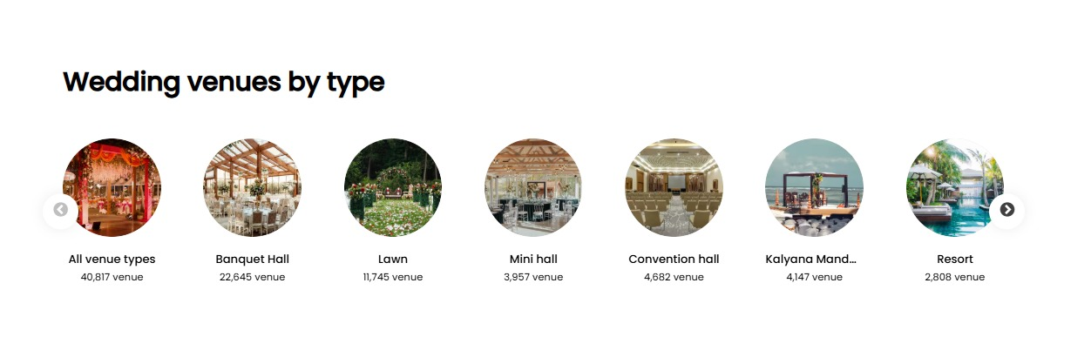

After login we have to hide below explore now part:

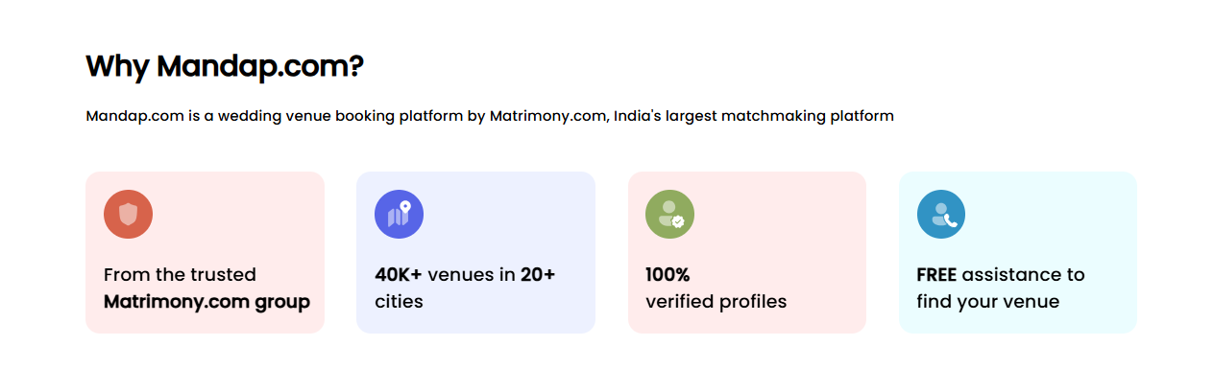

We want this before and after login:

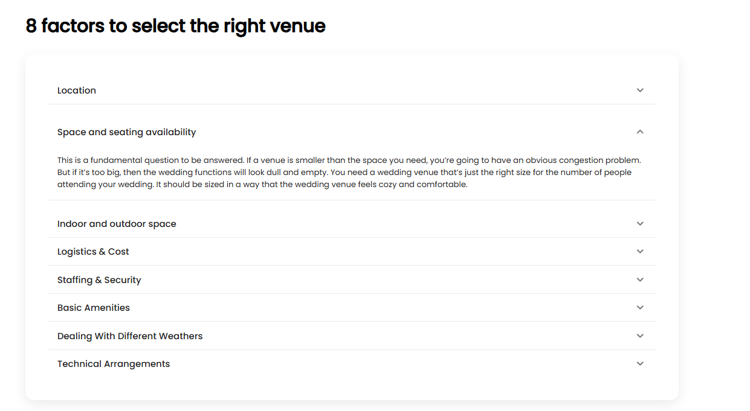

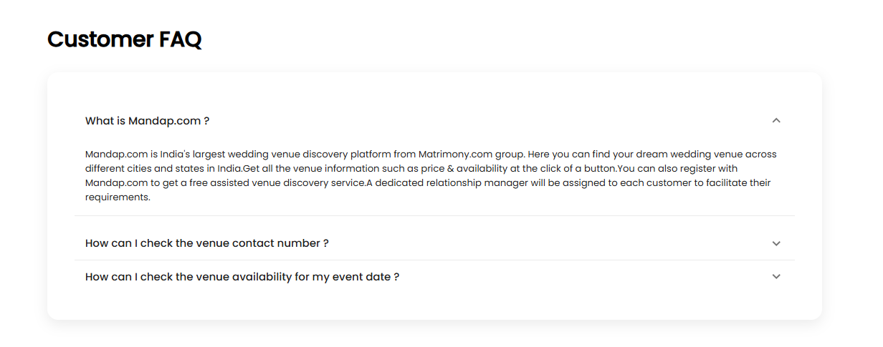

After login we have to hide below explore now part:



Link a static info page to explore now and show the benefits to add venue on the website.

At last we have to add register/login over there.

After login we have to hide below explore now part:

Reviews of cutomers(users) :

